A novel approach for detecting Fibroids in Uterus using Deep Learning models

Chellu Vyshnavi, Chukka Mishal Raj, Gokul Gopakumar, Guddeti Bindu Prasanna, Sreevidya B, Rajesh M.

Department of Computer Science and Engineering,

Amrita School of Computing, Bengaluru

Amrita Vishwa Vidyapeetham, India

[vyshnavichellu@gmail.com](mailto:vyshnavichellu@gmail.com) , [mishalchukka@gmail.com](mailto:mishalchukka@gmail.com) , [gokulgopakumar2002@gmail.com](mailto:gokulgopakumar2002@gmail.com), [binduprasanna3005@gmail.com](mailto:binduprasanna3005@gmail.com), [b_sreevidya@blr.amrita.edu](mailto:b_sreevidya@blr.amrita.edu) , [m_rajesh@blr.amrita.edu](mailto:m_rajesh@blr.amrita.edu)

*Abstract*— This work suggests a novel method that makes use of cutting-edge deep learning algorithms to detect fibroids in uterine ultrasound pictures. We tackle the common problem of unbalanced medical imaging datasets by achieving dataset balancing using the SMOTE. Additionally, we evaluate the fibroid detection performance of Deep Convolutional Generative Adversarial Networks (DCGANs), Residual Networks (ResNet50), InceptionV3, VGG16 and Convolutional Neural Networks (CNNs). For fibroid detection, we compare three different models: Deep Convolutional Generative Adversarial Networks (DCGANs), Residual Networks (ResNet50), InceptionV3, VGG16 and Convolutional Neural Networks (CNNs). Specifically, we evaluate their capacity to detect fibroids in uterine ultrasound pictures. Without integrating datasets, each model undergoes separate evaluation and training. Based on the results the most accurate model after balancing the dataset is CNN with an accuracy of 94.843%.

Keywords— CNN, SMOTE, ResNet50, VGG16, InceptionV3, DCGAN, synthetic fibroids.

# Introduction

Fibroids, also known as uterine leiomyomas, are prevalent benign tumors in the uterus that affect millions of women worldwide. The accurate detection of fibroids is critical for clinical diagnosis and therapeutic planning. Ultrasound, MRI, and CT scans are prominent medical imaging modalities used to diagnose fibroids, with ultrasound being the most accessible and safe. However, finding fibroids in ultrasound pictures as in Fig 1 and Fig 2 can be difficult, especially for small or inconspicuous tumors.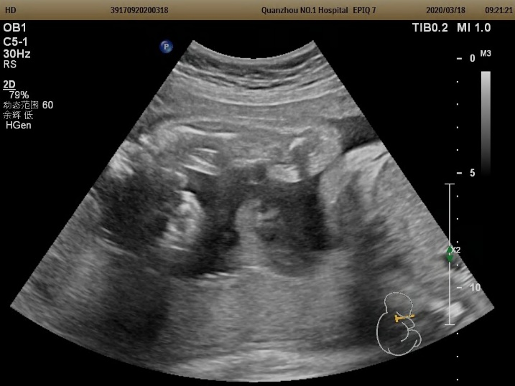Fig 1: Ultrasound Image of Non-Fibroid in Uterus

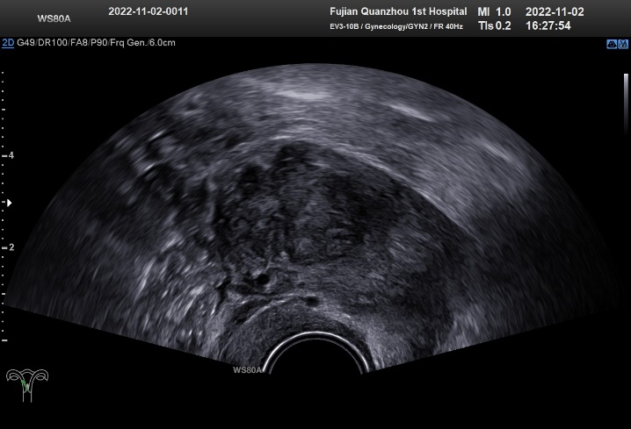Fig 2: Ultrasound Image of Fibroid in Uterus

SMOTE is used to rectify the class imbalance in the photo collection in order to identify fibroid tumors. By creating synthetic samples for the minority class, SMOTE balances the dataset by raising the representation of the minority class (fibroids) to equal that of the majority class (non-fibroids). This augmentation increases the overall detection accuracy of fibroids by ensuring that the model has sufficient training data for both groups and aiding in the identification of characteristics specific to fibroids.

By employing its distinct design for image processing to extract pertinent attributes through convolutional layers, CNN improves the accuracy of fibroid detection. When combined with methods like data augmentation and transfer learning, its capacity to identify complex patterns and textures linked to fibroids improves diagnostic accuracy. CNN enhances patient outcomes by facilitating accurate diagnosis and treatment planning for uterine fibroids through performance optimization through fine-tuning.

The Deep Convolutional Generative Adversarial Network, or DCGAN, increases the precision of fibroid diagnosis by generating realistic artificial images that resemble real fibroid patterns. Through the training of a discriminator to distinguish between real and fake fibroid images and a generator to produce convincing fibroid images, DCGAN obtains nuanced fibroid features, improving limited datasets and improving model generalization. More precise fibroid identification can result from DCGAN fine-tuning and transfer learning, which is crucial for early diagnosis and treatment planning.

The advanced architecture of ResNet50 increases the precision of fibroid identification. Skip connections facilitate the training of deeper networks by mitigating the effects of the vanishing gradient problem. By extracting specific features from uterine photos, ResNet50 may more reliably identify delicate fibroid patterns. Transfer learning and fine-tuning techniques improve its performance even further and enable accurate fibroid diagnosis. This establishes whether early diagnosis and treatment planning are necessary.

With its deep architecture, the well-known VGG16 model is able to extract advanced information from uterine pictures that improves the diagnosis accuracy of fibroid disorders. Through fine-tuning on our dataset, subtle patterns linked to fibroids are captured by VGG16, improving its precision. With VGG16 added to our detection technique, we expect increased precision that will help with uterine fibroids diagnosis and treatment planning.

InceptionV3's deep architecture improves the precision of fibroid diagnosis by extracting nuanced information from medical images. The diagnostic precision is improved by its capacity to obtain both high-level and low-level data using pre-trained weights and inception modules. InceptionV3 optimizes and applies transfer learning to reduce false positives in fibroid detection.

We present a new approach to uterine ultrasound image-based fibroid diagnosis and assess the performance of CNN, ResNet50, VGG16, InceptionV3 and DCGAN models. We mainly concentrate on balancing datasets with SMOTE. We address the problem of imbalanced datasets by utilizing SMOTE to guarantee a more representative distribution of fibroid and non-fibroid occurrences. In an effort to improve diagnostic precision in gynecological imaging, we compare the efficacy of CNN, ResNet50, and DCGAN models in correctly identifying fibroids.

# Literature Survey

Sabeeh et al. [1] proposed ultrasound scans to test deep learning models for uterine fibroid diagnosis, including VGG16, ResNet50, InceptionV3, and DPCNN. DPCNN has the highest accuracy rate (99.8%). The constraints include a limited dataset, reliance on a single imaging modality, and the requirement for model interpretability. Future study should concentrate on optimisation, interpretability, and large-scale dataset validation. Minu et al. [2] proposed DL models for uterine fibroid detection and classification utilizing a variety of datasets, including real-time ultrasound and magnetic resonance images obtained from hospitals and open-access sources. RefineNet, CE-Net, U-Net, and hybrid networks were all tested, and their accuracy rates varied. For example, the MBFC-DNN classifier is 94.73% accurate, but the Inception-V4-SVM and UFC models are 81.05% and 88.93%, respectively. Limitations include the need for greater diagnostic accuracy and generalizability. Future studies could focus on increasing resilience and reducing false positives and negatives. Ping et al. [3] proposed a real-time automatic aided diagnosis technique for uterine fibroids in ultrasound pictures that use an upgraded YOLOv3 deep learning detector. Uterine fibroids, a common benign tumor in women, are being targeted for early diagnosis to relieve symptoms and fertility issues. The approach is intended to be extremely accurate in detection. Limitations may include constraints on dataset size and diversity, variations in image quality, and the chance that alternative diagnoses will be overlooked. Chandrasekaran et al. [4] presents a DL approach utilizing a CNN to predict uterine fibroids from ultrasound images, aiming to enhance diagnostic accuracy. While the CNN architecture comprises convolutional, pooling, and fully connected layers, it's stressed that CNNs should complement, not replace, existing diagnostic tools. The methodology involves preprocessing, segmentation, and feature extraction, with promising results demonstrated on a dataset of 98 patients. The study underscores the need for further research to refine the method's accuracy and reliability, with potential integration into real-time clinical management systems. Shahzad et al. [5] DCNNs for automated uterine fibroid detection in ultrasound images. They compare the performance of pre-trained models (VGG16, ResNet50, InceptionV3) with a novel DPCNN architecture proposed by the researchers. The proposed DPCNN achieved the highest accuracy (99.8%), followed by InceptionV3 (90%) and ResNet50 (89%). However, limitations include unexplored temporal complexity of DPCNN and a relatively small training dataset (1057 grayscale images).

Yang et al. [6] proposed a diagnosis of uterine fibroids using manual film interpretation by physicians and ultrasonography. The time-consuming and subjective nature of these techniques may result in missed diagnosis. To get over these restrictions, deep learning presents a viable substitute. Applications of deep learning algorithms, such as convolutional neural networks (CNNs), for medical image analysis have shown promise. The accuracy of diagnoses can be increased by using CNNs to automatically extract information from medical images. Dilna et al. [7] proposed a Uterine fibroid and their identification from ultrasound pictures. Image processing, ML, and DL are among the detecting methods that are compared. With some of them reaching 99.8%, DL models had the greatest accuracy rates. On the other hand, several studies have found that older procedures can also be 95% accurate. Large datasets are required to train the algorithms, and distinguishing fibroids from other anomalies can be challenging. These are the limits of these techniques. John et al. [8] examines the application of Generative Adversarial Networks (GANs) to produce images, covering both conventional GANs and their variations, including DCGAN, WGAN, CGAN, and WGAN-GP. According to qualitative tests on the MNIST dataset, DCGAN generates images that are cleaner and more realistic, although WGAN-GP performs better quantitatively, as seen by the FID plot. Nevertheless, the study recognizes the shortcomings of the FID plot in assessing picture quality and the difficulties in gathering sizable datasets, which can result in overfitting. Ahmed et al. [9] discussed an automated method for identifying uterine fibroids in ultrasound pictures is proposed []. The TCGA-UCEC dataset's pictures are classified as either normal or having fibroids using a pre-trained VGG16 model. The report states that this is the best performance to date yet, with an accuracy of 98.5%. There is no mention of a literature review, however previous work probably used deep learning for uterine fibroid diagnosis or medical picture analysis in general. One pre-trained model to use and a dataset with potential size or scope constraints are two potential drawbacks. Devika et al. [10] presents a Dense Attentive Generative Adversarial Network (GAN) model for EMCI and PD detection that was trained on the OASIS-3 and PPMI datasets. The model outperformed previous techniques by utilizing dense blocks and self-attention modules, achieving 88.52% accuracy and 0.88 AUC in EMCI identification as well as notable gains in PD detection. The model's training on healthy samples from both datasets minimized possible performance degradation, despite acknowledging issues with cross-dataset variability. This made the model a promising diagnostic tool.

In order to identify uterine fibroids in ultrasound pictures, T. Yang et al.[11] emphasize the application of Scalable EfficientDet, which combines EfficientNet with BiFPN. The model obtains an F1-score of 98% and an average accuracy of 98.88%. It highlights the use of ultrasonography as a tool for experts and non-professionals alike, but it also raises concerns about possible limits in generalizability and reliance on particular data. A Voting Classifier makes the final predictions, and B. M. G. et al.[12] employ a hybrid ML model (Naïve Bayes + AdaBoost) and an ensemble ML model (Random Forest + Gradient Boosting). The models demonstrated an accuracy of 85% for Naïve Bayes + AdaBoost and 92% for Random Forest + Gradient Boosting when 10-fold Cross Validation was used. Limitations include the intricacy of disease-causing organisms that are always changing, which may reduce the accuracy of predictions, and the potential challenges of maintaining inadequate infrastructure in various locations. Srividya Tirunellai Rajamani et al.'s work[13] addresses the challenges in evaluating the state-of-the-art medical image segmentation models for practical application. It attacks utilizing average Dice scores as the only performance metric, without naming specific models. The study highlights how errors or model-produced anatomically erroneous outcomes can be missed by these measurements. It draws attention to the limitations of assessing model performance throughout the transition to clinical practice, as opposed to concentrating on the inherent shortcomings of specific models. Sudarsan et al.'s study[14] examines a number of ML algorithms, such as SVM, Decision Tree, Random Forest, Gaussian Naive Bayes, and a deep learning method known as 1D-CNN, for evaluating datasets pertaining to schizophrenia and Alzheimer's disease. The models' output is compared across these datasets, but specific evaluation metrics are not given. Notably, the author chooses the TADPOLE dataset due to its relatively low usage in research, instead of directly noting model constraints. K.S. Naveen Kumar et al. [15] provide text representation techniques (TF-IDF, Keras embedding) for sentiment analysis of tweets. They also investigate ML (Logistic Regression, SVM) and DL algorithms. It offers a 75.8% benchmark accuracy but no particular categorization stats. It examines the challenges of generalizing the model and maximizing its features, while acknowledging the benefits of SVM with more features and Logistic Regression with less. However, it ignores the limitations specific to deep learning models.

R. K. Pathinarupothi et al.[16] review of this research focuses on methods for sleep apnea diagnosis. Using multivariate sensor data, previous studies concentrated on blood oxygen saturation and respiratory rate . Minute-by-minute categorization accuracy has often fallen below 85%, despite recent studies on instantaneous heart rate and its derivatives. However, there are certain limitations to the accuracy of these heart rate-based techniques, especially when it comes to minute-by-minute classification of sleep apnea episodes. K, Sreelakshmi et al[17]presents three DL architectures for the identification of offensive language in Dravidian languages: a hybrid network that combines layers of Bi-RNN and Bi-LSTM with a hidden layer; and a Bi-LSTM layer network. The hybrid network demonstrated better training performance, while the paper does not give evaluation metrics. Rather than the DL models themselves, the main source of the paper's problems is the inherent class imbalance in the training data. The authors take a cost-sensitive learning technique to remedy this. Sriraam et al. [2] describes an automated method for uterine fibroids detection utilizing a backpropagation neural network (BPNN) classifier and wavelet packet characteristics. In order to determine the vertical and horizontal coefficients based on user-defined ROI, the approach applies a three-level wavelet packet decomposition. After that, pictures of the uterus are classified with a 95.1% classification accuracy using the BPNN classifier to identify between normal and fibroid uteri. The study makes use of 72 ultrasound scans from Precision Diagnostics Center in Chennai, India, of which 36 are normal and 36 are fibroid. Sensitivity, specificity, and classification accuracy are the metrics used by the authors to assess performance. This study's limitations include its tiny dataset size and absence of method comparisons.

# Proposed methodology

The important area of medical imaging is the detection of uterine fibroids from ultrasound images for timely treatment. However, it is the class imbalance in these datasets that creates the difficulty. That's why we move on to using advanced techniques in dataset balancing like SMOTE. Next, for deep learning models, we will compare some of those models on the balanced data, like ResNet50, DCGAN, InceptionV3, VGG16, and CNN, concerning accuracy and recall. The chosen model will try to improve the accuracy of diagnosis and patient outcomes in the detection of uterine fibroids. The issue of class imbalance in uterine ultrasound photos initially categorized into 'UF' and 'NUF' classes is addressed by creating 'train' and 'test' datasets. However, upon dataset preparation, the number of images between the 'UF' and 'NUF' classes shows a drastic difference, making the model biased toward the majority class, which is the 'NUF', while it underperforms toward the minority class, which is the 'UF'. That is why to remove the bias from the data, Synthetic Minority Over-sampling Technique is used, generating synthetic samples for 'UF' so that its number may equal the 'NUF' class. This technique ensures that the dataset is balanced in such a way that it enhances the model's ability to distinguish between fibroid and non-fibroid images, reducing biased training.

On the dataset balanced with SMOTE, the performance of different state-of-the-art models is evaluated, including Residual Networks (ResNet50), Deep Convolutional Generative Adversarial Networks (DCGAN), InceptionV3, VGG16, and Convolutional Neural Networks (CNN). Each model is trained on the balanced dataset, and key performance metrics like accuracy, precision, recall, and F1-score are used to determine their efficiencies in distinguishing between fibroid and non-fibroid images. The evaluation is comprehensive because it considers the recall of the real-world fibroid cases and the precision of the positive identifications. After that, the CNN model appeared to be the best fit for clinical use since it shows higher recall, accuracy, precision, and F1-score than other models. As such, CNN is proven to be a reliable tool for detecting fibroid and contributes to enhancing patients' outcomes and diagnostic accuracy.

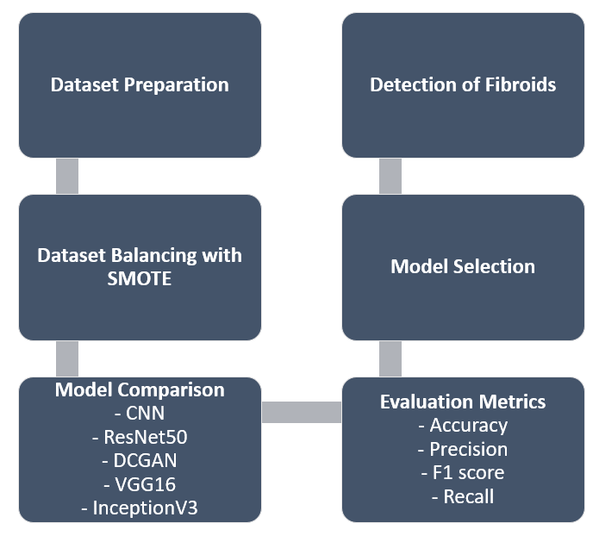

Fig 3: Flowchart for detecting Fibroids in Uterus

The Fig 3 here is a flowchart of a method that uses image analysis for the detection of uterine fibroids. The process starts with dataset preparation, which includes collecting and organizing medical images. After the isolation and segmentation of uteri from the images, careful marking of images is done to indicate the presence or absence of a fibroid. The SMOTE technique is then applied to solve the class imbalance problem, where images without fibroids would dominate the dataset. It synthetically creates samples from the minority category—images that contain fibroids—to effectively rebalance the dataset.

Thereafter, the flowchart presents the process of the selection and evaluation of machine learning models. Four kinds of CNN models are chosen—namely, CNN, ResNet50, VGG16, and InceptionV3—to be trained on the prepared dataset. Besides that, for every model, a set of measurements is performed, such as accuracy, precision, recall, and the F1 score. All these metrics provided bring out a clear understanding of the model's ability to identify fibroids in a valid manner. After the evaluation, a decision is made as to whether the model suffices. If the performance metrics can show sufficient effectiveness, then the model can be used in practice for real-world applications.

# experiments and results

## Experimental Setup

Preparation of the data is the first step. The images in this case are medical images, and they are gathered and prepared through the segmentation of the uteri and the labeling of their presence or absence with fibroids. To counteract possible class imbalance in which there may be significantly more images without fibroids, Synthetic Minority Oversampling Technique is applied. The application of SMOTE, adding synthetic examples of the minority class to the images with fibroids, makes a balanced training dataset.

Data preparation is followed by model selection and evaluation. The other models have been brought out as depicted in Fig 3: other five convolutional neural networks that would be used consist of CNN, ResNet50, VGG16, and InceptionV3. Most important is the fact that DCGAN is also applied; it is a Deep Convolutional Generative Adversarial Network. Unlike the other CNNs designed for classification, DCGAN is a generative model and would not classify images directly. Its role might be to explore generating synthetic medical data to further augment the dataset.

Training of all models on the prepared dataset is done. Afterwards, their performance is evaluated by a comprehensive set of metrics: accuracy, precision, recall, and the F1 score. Accuracy reflects the overall proportion of correct classifications. Precision focuses on the proportion of positive predictions that are truly positive—identification of actual fibroids. Recall focuses on the proportion of actual positive cases the model correctly identifies—images with fibroids correctly classified. The F1 score provides a balanced view of both precision and recall.

## Results

The table1 shows the accuracy of five different models for detecting fibroids in a uterus before and after balancing the dataset using SMOTE. SMOTE is a technique used to address class imbalance. Class imbalance occurs when a dataset has a significant skew towards one particular class. In this case, the dataset likely has more images without fibroids than with fibroids.

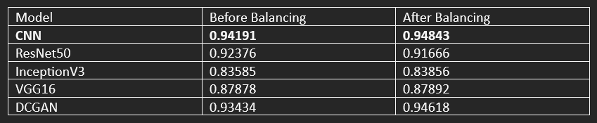

Table1. Accuracies of each model before and after balancing the dataset using SMOTE

**CNN:** The accuracy increased from 0.94191 to 0.94843 after balancing the dataset.

**ResNet50:** The accuracy decreased from 0.92376 to 0.91666 after balancing the dataset.

**InceptionV3:** The accuracy increased slightly from 0.83585 to 0.83856 after balancing the dataset.

**VGG16:** The accuracy increased slightly from 0.87878 to 0.87892 after balancing the dataset.

**DCGAN:** The accuracy increased from 0.93434 to 0.94618 after balancing the dataset.

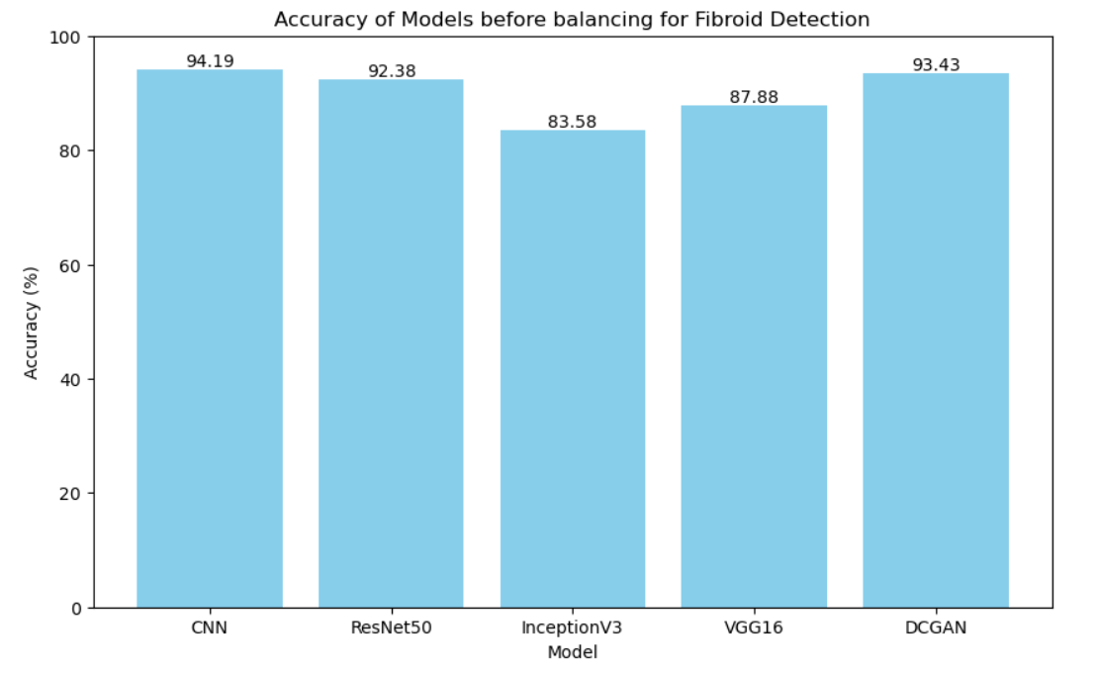

Fig 4: Comparing the accuracies of each model before balancing dataset

In Fig 4., it shows the accuracy of the different deep learning models in what appears to be a medical diagnosis task, probably fibroid detection, before balancing. The labels on the x-axis include the models: CNN, ResNet50, InceptionV3, VGG16, and DCGAN. The accuracy is on the y-axis, which ranges from 20 to 100%. All of them perform below 100% accuracy; DCGAN performs the worst at 83.58% and CNN performs best at 94.19%. This means no model perfectly differentiates fibroids from non-fibroids in this dataset.

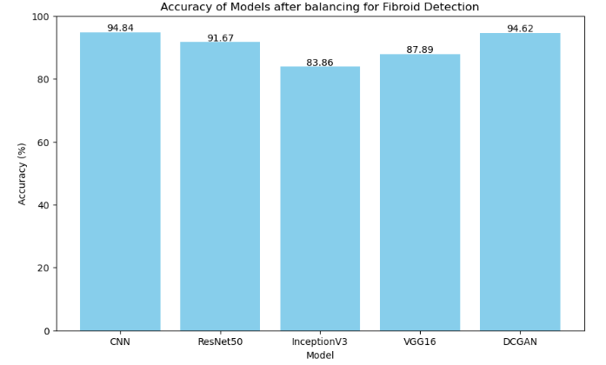

Fig 5: Comparing the accuracies of each model after balancing dataset

The graph in Fig 5., is a bar graph comparing accuracy for different deep learning models for a medical diagnosis task; here, probably, the detection of fibroids is a task. Along the X-axis, the models are CNN, ResNet50, InceptionV3, VGG16, and DOGAN. On the Y-axis is the accuracy; it ranges between 20% and 100%. There is no accuracy of 100% for any model. DCGAN had the lowest at approximately 83.86%, and the best by CNN at approximately 94.84%. That would give an indication that none of the models is able to distinguish fibroid and not perfectly for fibroid on this dataset. However, high accuracy results for CNN and ResNet50 suggest these models are suitable for this task after further evaluation.

Based on the results in the table, the most accurate model after balancing the dataset is CNN with an accuracy of 94.843%.

# Conclusion and future scope

The main goal of our experiment was to use multiple deep learning models to detect uterine fibroids. We were able to effectively balance the classes in our image dataset by using the SMOTE to address the issue of class imbalance. Following that, we trained several models, such as CNN, VGG16, ResNet50, InceptionV3, and DCGAN. After balancing the dataset, our analysis revealed that the CNN model had the highest accuracy, coming in at 94.84%. This implies that CNN fared better in identifying fibroids than other models, suggesting its suitability for medical image processing applications. Our findings demonstrate the potential of CNN as a trustworthy tool for fibroid detection, which will promote medical diagnosis and treatment planning, and they support the application of appropriate approaches to decrease class imbalance.

##### References

1. A. Shahzad, A. Mushtaq, A.Q. Sabeeh, Y.Y. Ghadi, Z. Mushtaq, S. Arif, M.Z. Ur Rehman, M.F. Qureshi, and F. Jamil, "Automated Uterine Fibroids Detection in Ultrasound Images Using Deep Convolutional Neural Networks," Healthcare (Basel), vol. 11, no. 10, pp. 1493, May 20, 2023.
2. M. I. Shanthini Watson Benjamin and J. Visumathi, "Comparative Analysis of Image Based Uterus Fibroid Detection and Classification Using Deep Learning," in 2023 International Conference on Advances in Computing, Communication and Applied Informatics (ACCAI), Chennai, India, 2023.
3. T. Yang, L. Yuan, P. Li, and P. Liu, "Real-Time Automatic Assisted Detection of Uterine Fibroid in Ultrasound Images Using a Deep Learning Detector," Ultrasound in Medicine & Biology, vol. 49, no. 7, pp. 1616–1626, Jul. 2023.
4. C. R, P. K, G. R, and U. Mutheeswaran, "Prediction of Uterine Fibroids from Ultrasound Images," in 2023 3rd International Conference on Advance Computing and Innovative Technologies in Engineering (ICACITE), Greater Noida, India, 2023.
5. Z.-P. Jiang, Y.-Y. Liu, Z.-E. Shao, and K.-W. Huang, “An Improved VGG16 Model for Pneumonia Image Classification,” Applied Sciences, vol. 11, no. 23, doi: 10.3390/app112311185, 2021.
6. S. Rajpal, N. Lakhyani, A. K. Singh, R. Kohli, and N. Kumar, “Using handpicked features in conjunction with ResNet-50 for improved detection of COVID-19 from chest X-ray images,” Chaos, Solitons & Fractals, vol. 145, p. 110749, doi: https://doi.org/10.1016/j.chaos.2021.110749, 2021.
7. D. k t, A. Jude, A. Angelopoulou, E. Kapetanios, T. Chaussalet, and J. D, “Classification of Uterine Fibroids in Ultrasound Images Using Deep Learning Model,” pp. 50–56. doi: 10.1007/978-3-031-08757-8_5, June 2022.
8. M. John and S. Santhanalakshmi, "Image augmentation using GAN models in Computer Vision," in 2021 2nd International Conference on Smart Electronics and Communication (ICOSEC), Trichy, India, pp. 1194-1201, doi: 10.1109/ICOSEC51865.2021.9591692, 2021.
9. Z. Ahmed, M. Kareem, H. Khan, Z. Saman, and F. Hassan Jaskani, "Detection of Uterine Fibroids in Medical Images Using Deep Neural Networks," EAI Endorsed Transactions on Energy Web, vol. 1, pp. 13, doi: 10.4108/EW201222.31232, 2022.
10. D. K and V. R. Murthy Oruganti, "Two Birds with One Stone: A Dense Attentive GAN-based Model for Detecting Alzheimer's and Parkinson's Disorders," in 2024 14th International Conference on Cloud Computing, Data Science & Engineering (Confluence), Noida, India, pp. 314-319, doi: 10.1109/Confluence60223.2024.10463487, 2024.
11. T. Yang, P. Li, and P. Liu, "Efficient Automatic Detection of Uterine Fibroids Based on the Scalable EfficientDet," in 2022 IEEE 16th International Conference on Anti-counterfeiting, Security, and Identification (ASID), Xiamen, China, pp. 157-160, doi: 10.1109/ASID56930.2022.9996062, 2022.
12. B. M. G. et al., "Disease Prediction Based on Symptoms Using Ensemble and Hybrid Machine Learning Models," in 2024 14th International Conference on Cloud Computing, Data Science & Engineering (Confluence), Noida, India, pp. 799-804, doi: 10.1109/Confluence60223.2024.10463480, 2024.
13. S. T. Rajamani, K. Rajamani, A. Venkateshvaran, A. Triantafyllopoulos, A. Kathan, and B. W. Schuller, "Toward Detecting and Addressing Corner Cases in Deep Learning Based Medical Image Segmentation," in IEEE Access, vol. 11, pp. 95334-95345, doi: 10.1109/ACCESS.2023.3311134, 2023.
14. D. Sudharsan et al., "Analysis of Machine Learning and Deep Learning Algorithms for Detection of Brain Disorders Using MRI Data," in M. Gupta, S. Ghatak, A. Gupta, and A. L. Mukherjee (Eds.), Artificial Intelligence on Medical Data, vol. 37, Springer, Singapore, pp. 1-15, doi: 10.1007/978-981-19-0151-5_4, 2023.
15. K. S. Naveenkumar, R. Vinayakumar, and K. P. Soman, "Amrita-CEN-SentiDB: Twitter Dataset for Sentimental Analysis and Application of Classical Machine Learning and Deep Learning," in 2019 International Conference on Intelligent Computing and Control Systems (ICCS), Madurai, India, pp. 1522-1527, doi: 10.1109/ICCS45141.2019.9065337, 2019.
16. R. K. Pathinarupothi, R. Vinaykumar, E. Rangan, E. Gopalakrishnan, and K. P. Soman, "Instantaneous heart rate as a robust feature for sleep apnea severity detection using deep learning," in 2017 IEEE EMBS International Conference on Biomedical & Health Informatics (BHI), Orlando, FL, USA, pp. 293-296, doi: 10.1109/BHI.2017.7897263, 2017.
17. S. K, P. B, and S. Kp, “Amrita-CEN-NLP@DravidianLangTech-EACL2021: Deep Learning-based Offensive Language Identification in Malayalam, Tamil and Kannada,” in Proceedings of the First Workshop on Speech and Language Technologies for Dravidian Languages, pp. 249–25, Apr. 2021.
18. N. Sriraam, D. Nithyashri, L. Vinodashri, and P. M. Niranjan, "Detection of uterine fibroids using wavelet packet features with BPNN classifier," in 2010 IEEE EMBS Conference on Biomedical Engineering and Sciences (IECBES), Kuala Lumpur, Malaysia, pp. 406-409, doi: 10.1109/IECBES.2010.574, 2010.